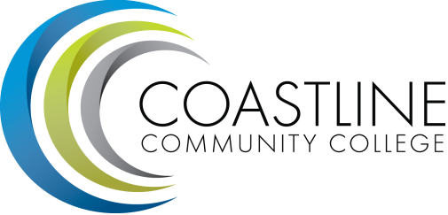

Classified Senate Meeting Agenda
Thursday, March 19, 2015
10am - noon
4th floor conference room, College Center

CALL TO ORDER (5 minutes)
  - Roll Call
  - Welcome: Mark W.
  - Adoption of Agenda
  - Approval of Minutes

SPECIAL REPORTS/UPDATES (5 minutes)
  - College Events
President’s Cabinet Open Forum Lunch: Today, Noon - 1 PM GGC Room 207
Art Gallery Craft Fair: April 2, Noon - 8:00 PM at the NBC
Scholarship Awards Ceremony: April 9, 6 PM - 8:30 PM OCC Robert Moore Theatre
Spring Transfer Fair: April 22, 10 AM - 1 PM at the NBC
Art Gallery Summer 2015 Workshop: July 22 - 24, 10 AM - 4 PM
Gerontology Networking Event: September 2, 6:30 PM - 8:30 PM at the NBC
OC Global Women’s Conference: May 29, 8 AM - 2:30 PM at the Hilton Irvine/OC Airport
  - Accreditation visit:
The accreditation team will visit on April 6. Dr. Kimberly Perry and Erica LeBlanc.

ACTION ITEMS (40 minutes)
  - Presentation of PACE results: Aeron Zentner, DBA
  - Scholarships: Diana A.

STANDING REPORTS (10 minutes)
  - Committee Reports:
  - Academic Senate Report: Marilyn Fry

DISCUSSION ITEMS (10 minutes)
  - Common Committee Calendar: Mark W.
  - Coastline’s Mission Statement: Mark W.
  - Elections are approaching. Next years officers wanted.

ANNOUNCEMENTS (5 minutes)
  - Meet the Chancellor. Thursday, April 9, 9am - 10am, College Center 4th floor.

ADJOURNMENT
Next Meeting: April 16, 2015

